STUDENT NAME: BANDOY, GIELO MAR R.  
COURSE/YEAR/SEC: BSCpE 3A  
SUBJECT: COMPUTER ENGINEERING DRAFTING AND DESIGN  
INSTRUCTOR: ENGR. LEVI CORVERA

CIRCUIT: 2 OUTPUT – REGULATED POWER SUPPLY

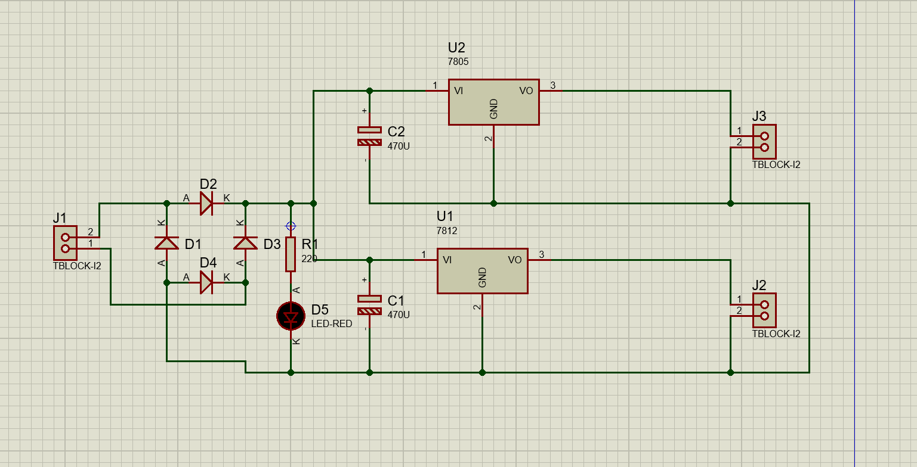

CIRCUIT: RUNNING LIGHTS – USING NE555 TIMER AND CD4017.

